22.31: a)
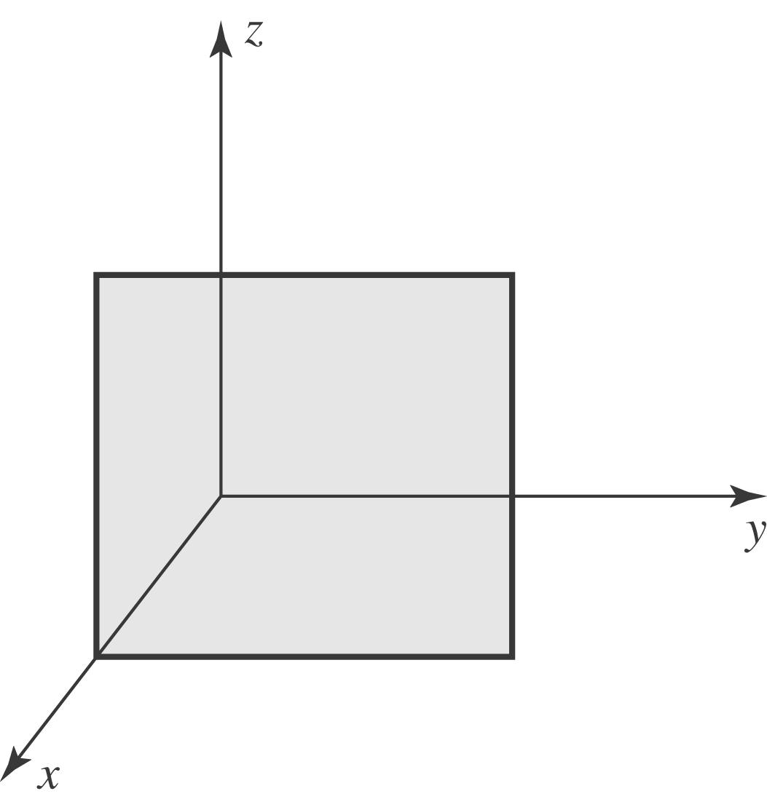

b) Imagine a charge q at the center of a cube of edge length 2L. Then: 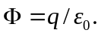 Here the square is one 24th of the surface area of the imaginary cube, so it intercepts 1/24 of the flux. That is, 